Contents

Managing Director’s Statement 3
Statement of Purpose 4
Our Strategy 5
Organisation and Responsibilities 6

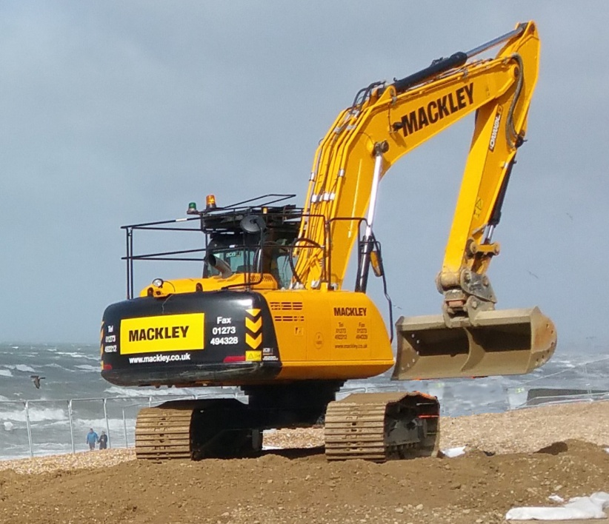

This policy statement 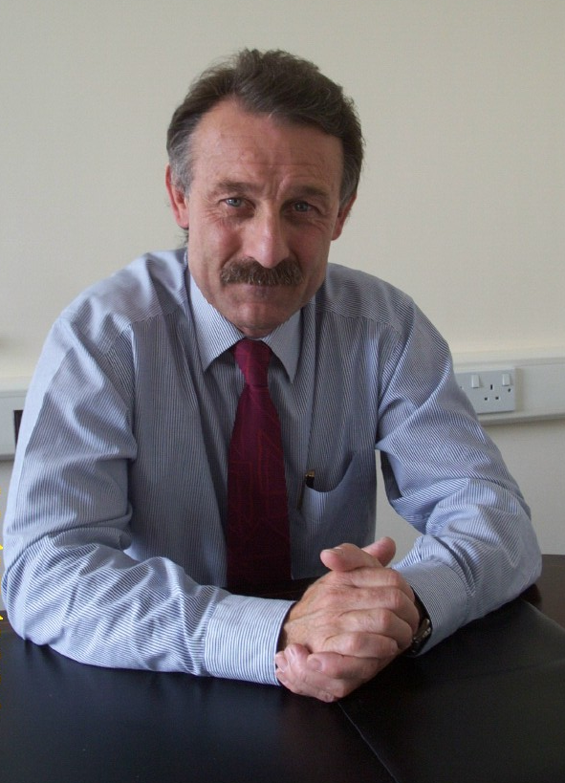provides a framework for managing the quality, occupational health, safety environment issues facing Mackley.

The company aims to achieve first class performance in quality, health, safety and environment by reducing and managing risks, eliminating potential injuries, preventing work related ill-health and minimising the effect of our activities on the Environment

Providing a professional service and quality products without compromising the health and safety of the public, our workforce and the protection of the environment, is integral to the company and will remain the prime responsibility of management at every level.

Wherever Mackley operates we are committed to achieving the highest level of performance, we will plan our works to achieve our clients quality expectations and maintain that an excellent health, safety and environment record makes good business sense.

Mackley aims to continually improve its performance in order to at least comply with changing business and regulatory needs and will always ensure that our policies and management systems will be reviewed every year, or at such a time as changes in legislation come into force, to ensure that they reflect any changes.

AJ Camilleri
Managing Director

Reviewed February 2016

Our Purpose: To be the industry leader in Quality, Health, Safety and Environmental performance.

- To provide high quality services and products to our customers and stakeholders.
- Develop a clear, shared vision of excellent safety, health and environmental stewardship where every individual is proud to belong and encouraged to excel.
- We will plan our work to achieve "right first time", and zero returns for defective work.
- Ensure that project teams always consider risks to health safety and environment.
- Work efficiently and effectively, sharing knowledge, and seting minimum standards which will be comparable with, or exceed the best that industry has to offer.
- Senior management lead by example, listening to every employee and considering seriously any idea or innovation, to take every opportunity to change or adapt our systems and processes to permanently change, for the better, our ways of working.
- We will promote sustainable construction and minimise environmental and social impacts, protecting areas with environmental designations and priority species.
- Create and improve wildlife habitat and seek environmental enhancement at every opportunity.
- We will use PEFC/FSC Chain of Custody Certified timber or timber with evidence of sustainable supply on all projects undertaken by the company
- Ensure everyone working on our projects are adequately resourced, and competent to lead on quality, health, safety and environment in their area of responsibility.
- We know that from time to time there will be problems. We will use these as positive opportunities to ensure we learn, continue to improve and to excel at what we do, so that we are defined by what we are becoming and not by what we have been.
- Progress towards achieving a Beyond Zero culture will always be the principle driver of our safety, health and environmental programme. However, we recognise that clients will wish to make numerical comparisons and we will use appropriate benchmarks. In particular, we commit to a target of zero accidents caused by management systems failures.

Strategy for Quality, Health Safety and Environment.

Through line managers, Mackley will encourage the contribution and involvement of all staff, suppliers and clients involved with our work and in particular:-

- Identify risks and opportunities to maintain or improve quality, health, safety and environment.

- For each project develop a clear plan or plans to make full use of opportunities for improvement, and prevent or minimise risks. Our plans will take account of annual corporate objectives.

- We will regularly check the effectiveness of our arrangements and adapt them as appropriate.

- Communicate with our staff regularly so that they are aware of our objectives, plans, detailed arrangements and are able to challenge and contribute to them.

- Adopt working methods which minimise waste and support sustainable construction techniques. Wherever possible we will seek to enhance the environment and habitats of the places we work.

- Enhance the economy of the communities within which we work by encouraging the use of local and small, medium sized enterprises on our projects.

- The company will adopt a quality based management approach, using recognised ISO9001, 14001 and 18001 standards to ensure standards are maintained and externally verified.

- Whilst the primary responsibility for quality, health, safety and the environment rests with line managers, the company will provide support and advise toall its staff through a professional QHSE team and in particular ensure that:-

- Staff are properly trained
- Company systems and policies are maintained and communicated.
- Performance of sites are monitored and shortfalls addressed.
- Company performance is understood and the Board, and Management Team kept informed of threats and opportunities.
- When problems arise that they appropriately are reviewed and lessons learnt.
Organisation

The Managing Director and Board | The Managing Director is responsible, through the Mackley Board, for the effectiveness of the company’s health, safety and environment management system.  The board will treat Health, Safety and the Environment as a core business requirement, and where necessary, prioritise it over all other considerations.  Board members will individually and corporately encourage and support Mackley staff who raises concerns or opportunities for improvement  The Board will ensure that the resources are in place to achieve excellent performance including the necessary arrangements to monitor and report compliance against this policy.
All managers  (including supervisors) | Managers have responsibility for the day-to-day control of the company’s core activities.  Managers are responsible for ensuring that their staff, sub-contractors and service providers comply with company policies and procedures.  Line Managers are required to set targets, monitor and report on performance, allocate resources, facilitate communication and ensure the competency of employees, sub-contractors and service providers.  Managers may seek advice and guidance from the company’s QHSE team.
QHSE Manager | The QHSE specialist with the support of the QHSE team is the competent person employed to provide advice, guidance and assistance on issues associated with quality, health, safety and environment.
All Roles | We are all expected to:  Co-operate and assist in the implementation of this policy, whilst ensuring that their own works, are carried out professionally, safely, without harm to environment and to our clients expectations of quality.  Maintain a healthy, and positive workplace, and if necessary, prioritising health safety and protection of the environment over all other considerations.  Be co-operative, follow company procedures, use the supplied work equipment and personal protective equipment in accordance with your training.  Lead by example, thinking about the safety of yourself, others and the environment.  Comply with the law and enhance the company's reputation.  Take a positive approach to identifying potential risks and eliminating or minimising them.  Contribute to everyone's wellbeing by informing line management of any injuries, ill-health, potentially unsafe or environmentally threatening situations, or ‘near misses’.
Consultation | The company recognises the importance and value of its informal communication however it will also ensure that formal consultation opportunities exist as appropriate to the scale and complexity at every work location and as a minimum:-  At work sites, a site induction, daily briefing, method statement briefing, and inclusion of QHSE as an agenda item in all progress meetings.  At office locations, a company induction and the inclusion of QHSE on agendas of all management meetings.

